Project Design Phase
Solution Architecture
Date | 27 September 2026
Team ID | SWTID-2026-7148
Project Name | AI Weatherwise API
Maximum Marks | 2 Marks

Solution Architecture
Solution architecture is the process of designing the technology structure needed to solve a business problem. It connects business requirements with suitable technical solutions.
Goals:
- Identify the right technology to solve the problem.
- Define the system structure, components, and behavior.
- Specify features, requirements, and development stages.
- Provide a clear plan for developing and delivering the solution.
Example - Solution Architecture Diagram:
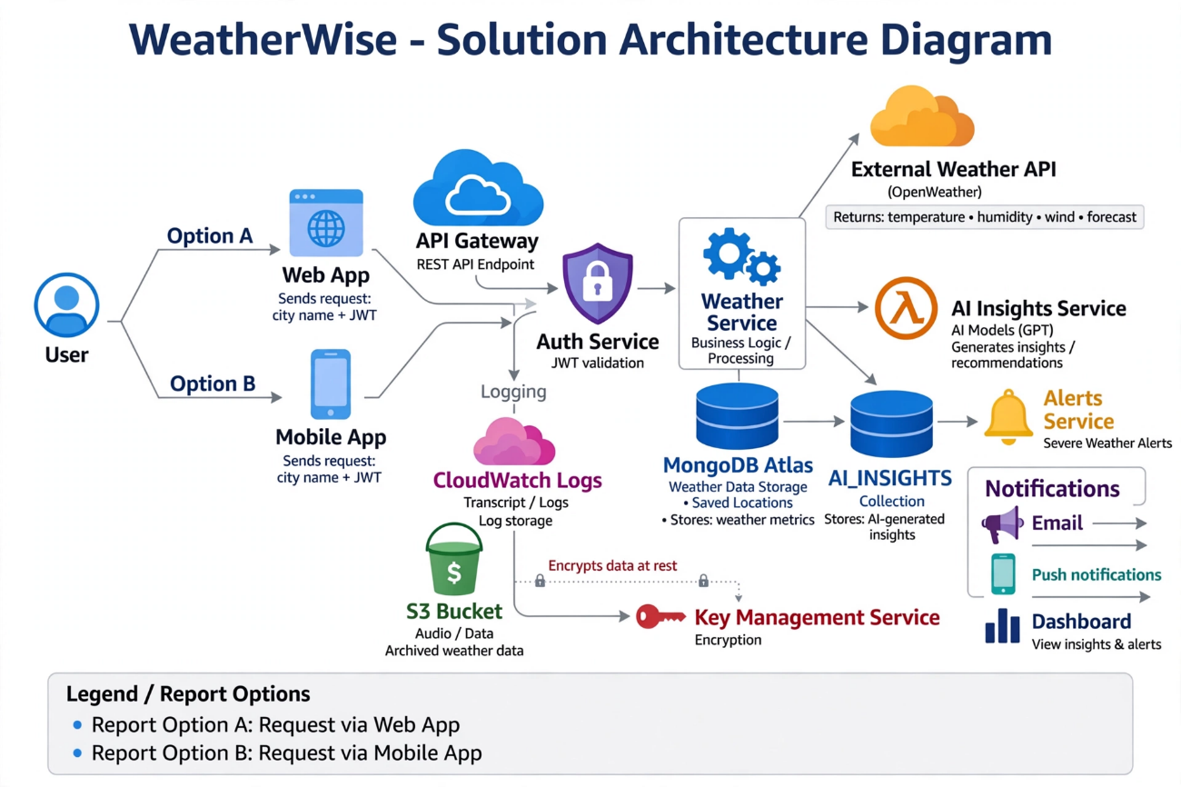
Reference:
https://www.atlassian.com/agile/tutorials/epics
https://www.atlassian.com/agile/tutorials/sprints

